OFFSHORE PISTON CORE SAMPLING PROTOCOL

- Upon core retrieval, the core is placed in a trough.

- All excess water and debris is removed from core liner using paper towels.
- The depth of disturbed sediment is determined, if less than 3” place sample in bag using spatula and label with Job #, Core ID, Section 1, depth, and date, otherwise cut core to end of disturbed sediment and label core section as Section 1.

- Starting at the end of the core, (0 ft or the surface of the sediment), measure 3 ft (or 1 m) and mark liner. Then measure to 6 ft , 9 ft, 12 ft, 15 ft, (or 2m, 3m, 4m), etc. (All sections except for the first and last section should be 3 ft (or 1m) in length)

- Label each section on the core liner with Job #, Core ID, Section #, Top depth, Bottom Depth, and date with an arrow pointing to the top of the section.

- Place the top cap and tape with electrical tape only once around the cap.

- Using the core liner cutter, cut the core at the next section break while supporting the liner horizontally.

- The soil in the core liner is cut using a wire.

- The bottom end of the section is capped immediately after cutting and taped with BLACK electrical tape securely.

- The section is carried into the lab and stored vertically with the top up.

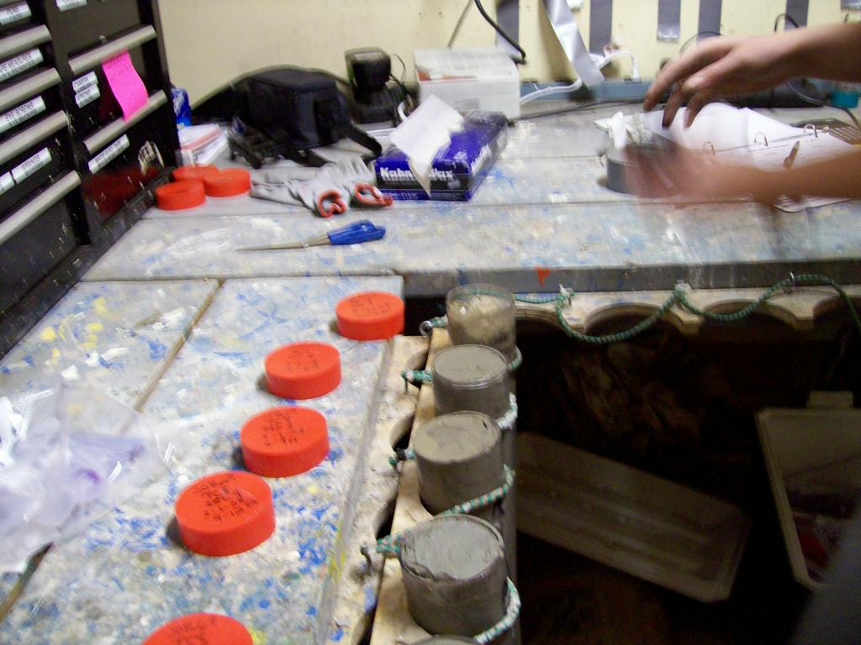

- The top cap of each section is labeled with Job #, Core ID, Section #, depth and date.

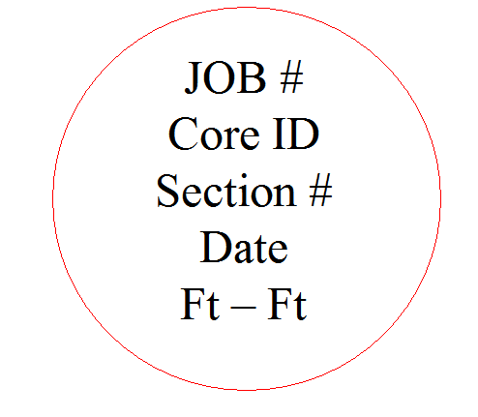

- A digital picture of the top of each section and cap is taken by holding the cap level with the core section. Use the close up option (the option is labeled with a flower on the camera) without flash to prevent glare (see example).

- A visual description is recorded, noting water content, cohesion, forams, and color (using Munsell color chart). Also record any other observations in the comments section (i.e. odors, minor liner damage, etc.)

- Torvane and minivane testing are conducted at the top of each section and the bottom of the last section.

- If requested by client: The tested soil (or at least 4” of sediment) is removed from the core and placed in a bag labeled with Job #, Core ID, Section #, depth of removed soil (ex. 3’-3’4”), and date.

- If there is an empty space in the liner, ensure there is a level surface at the top of the sediment. If there is not, make the surface level by gently removing the smallest amount of sediment possible using a spatula. Minimize disturbance of the sediment.

- If requested by client: A square piece of wax paper is placed in the core at the depth of the removed soil.

- If requested by client: Hot wax is poured on the wax paper and allowed to cool.

- If there is a gap in the liner, a foam noodle tube is placed on top of the cooled wax and cut even with the end of the liner to prevent shifting of the sample. Do not force the sediment down into the liner.

- The top cap is placed on each section and securely tapped with WHITE electrical tape.

- The core sections are stored and secured in a vertical position with the deep portion of the section on the bottom (White electric tape at the top).

